⁠Deep Learning with limited data - CNNs and small labelled datasets

Approaches to avoid overfitting to small or imbalanced datasets:

- Model architecture selection
Limiting the size of the model used ( eg ‘shallow’ learning, AlexNet vs VGG vs SquuezeNet (Emersic, Stepec, Struc, & Peer, 2017))

- unsupervised pre-training (Wagner, Thom, Schweiger, Palm, & Rothermel, n.d.)⁠

- transfer-learning – “The transfer of knowledge across learning tasks seems to play an essential role for generalizing accurately, particularly when training data is scarce” (Thrun, 1996)
Transfer learning refers to the idea of applying a model learnt for a related task to a new, usually similar, task, as a starting point. For instance, the task of detecting oranges in an image shares many similarities with detecting apples, it involves identifiying edges, shapes, etc.
Data pooling: can the model use another model as a starting point? Eg other animals or humans?
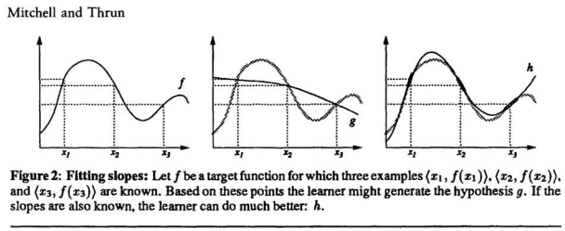
- Understanding the data better...
The ability to ‘explain’⁠ how a data point fits into the model/function (Explanation-Based Neural Network Learning) (Mitchell & Thrun, 1993)
Similar idea generative models perhaps, in the sense that both approaches attempt to understand more about the actual data. (https://blog.openai.com/generative-models/)
“In addition to generating pretty pictures, we introduce an approach for semi-supervised learning with GANs that involves the discriminator producing an additional output indicating the label of the input. This approach allows us to obtain state of the art results on MNIST, SVHN, and CIFAR-10 in settings with very few labeled examples. On MNIST, for example, we achieve 99.14% accuracy with only 10 labeled examples per class with a fully connected neural network — a result that’s very close to the best known results with fully supervised approaches using all 60,000 labeled examples. This is very promising because labeled examples can be quite expensive to obtain in practice.”
I don’t know how we would determine the slope of each data point in the above picture however, or how generative models apply to limited datasets in regression or classification problems.

- “Selective Model Learning” (Emersic, Stepec, Struc, & Peer, 2017)
Use of a pre-trained CNN for feature extraction, appending the layers.

- Model Averaging
Multiple training runs from random initial weights, where the final weights are are a combination of each run.
  - The interdependence of the weights may be lost if this approach is used?
  - Approach described by Rohit

- Remixing of the validation set with the training set between iterations, so as to avoid overfitting to either

- Data cleaning
  - Regularisation. Can this be applied to visual data?
    - Reduces DoF without removing actual no. of parameters, ie pixel count
    - L1 vs L2 reg
  - Removal of outliers
- Data augmentation (https://github.com/aleju/imgaug)

Can it be reformatted as semi-supervised, to take advantage of unlabelled data?

“by selecting an appropriate model architecture, using aggressive data augmentation and selective learning on existing (pre-trained) models, we are able to learn an effective CNN·based model using a little more than 1300training images” (Emersic, Stepec, Struc, & Peer, 2017)

References:

Emersic, Z., Stepec, D., Struc, V., & Peer, P. (2017). Training Convolutional Neural Networks with Limited Training Data for Ear Recognition in the Wild. Proceedings - 12th IEEE International Conference on Automatic Face and Gesture Recognition, FG 2017 - 1st International Workshop on Adaptive Shot Learning for Gesture Understanding and Production, ASL4GUP 2017, Biometrics in the Wild, Bwild 2017, Heteroge, 987–994. https://doi.org/10.1109/FG.2017.123
Mitchell, T. M., & Thrun, S. B. (1993). Explanation-based neural network learning for robot control. Advances in Neural Information Processing Systems, 287. Retrieved from http://citeseerx.ist.psu.edu/viewdoc/download?doi=10.1.1.41.9874&rep=rep1&type=pdf
Thrun, S. (1996). Is Learning The n-th Thing Any Easier Than Learning The First? Advances in Neural Information Processing Systems, 7. https://doi.org/10.1.1.44.2898
Wagner, R., Thom, M., Schweiger, R., Palm, G., & Rothermel, A. (n.d.). Learning Convolutional Neural Networks From Few Samples. Retrieved from http://geza.kzoo.edu/~erdi/IJCNN2013/HTMLFiles/PDFs/P274-1108.pdf
⁠

